**1. My Posted Jobs**

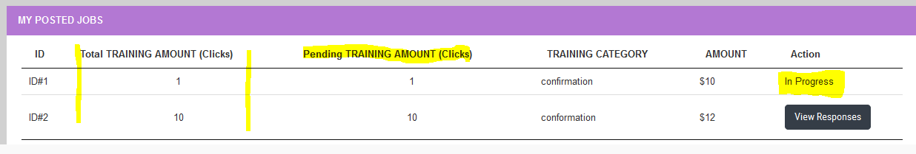

- Total Training amount (clicks) was showing blank earlier. This has been fixed.

- Pending training clicks column added to track progress

- Job Status feature added, which will display following status:

a) Accepted (if job is applied and accepted by employer)

b) In Progress (when employee starts working on that job)

c) Completed (when job is completed)

So, "View Responses" button will show only for those jobs which are still open and not accepted.

**2. Applied Jobs**

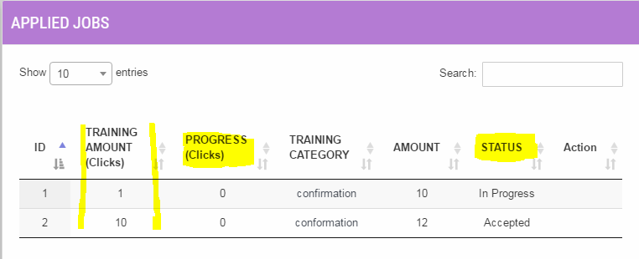

- Training amount (clicks) were showing blank earlier. Issue fixed.

- Progress column added to show number of clicks done so far.

- Status column updated to show correct job status

- "Visit Training Centre" Link added

**3. Alert Messages Box on Kennel Page added**

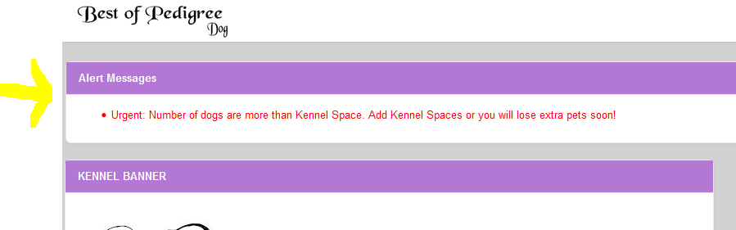

**4. Service added that remove extra dogs from kennel**